Screen shots of POST MAN

* GET Request  
  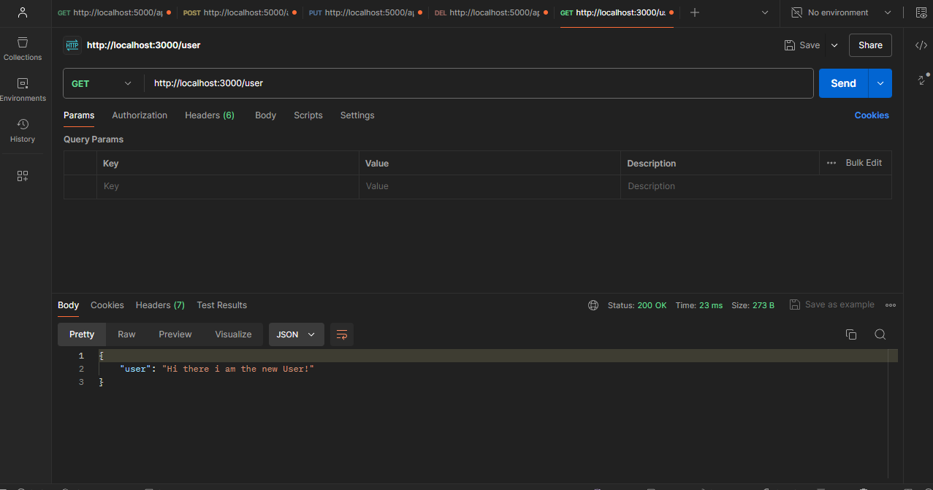
* POST Request

* PUT Request and Id was randomly given to test that

DELETE Request and Id was randomly given to test that

